# **Program 01 (Quadratic Equation).**

## Quick link: - <https://dotnetfiddle.net/SdRVst>

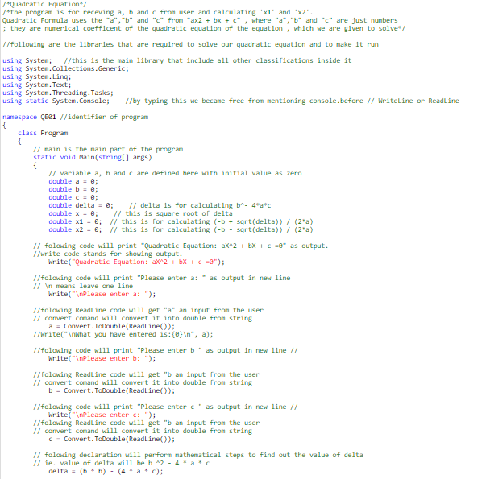

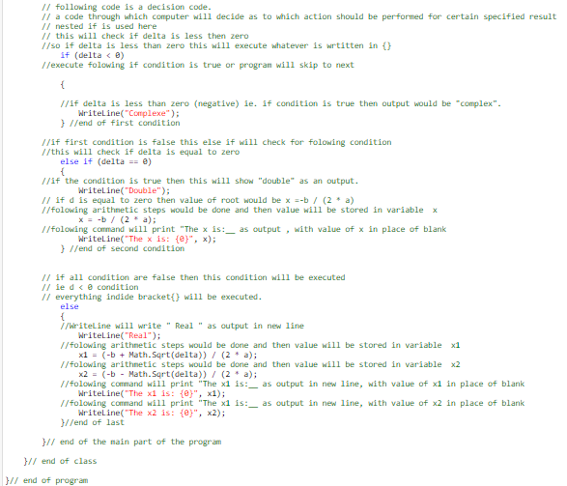

# **Program 02 (Finding week days using nested if)**

Quick link: - <https://dotnetfiddle.net/CGEQVT>

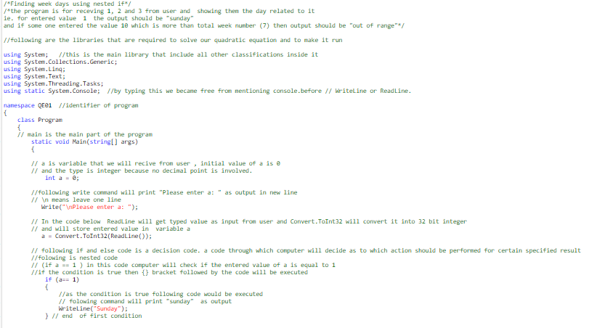 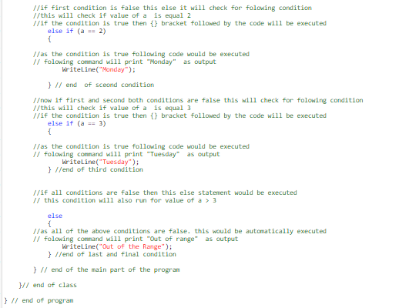

# **Program 03 (Using if and && to find students mark)**

Quick link: - <https://dotnetfiddle.net/IWaXek>

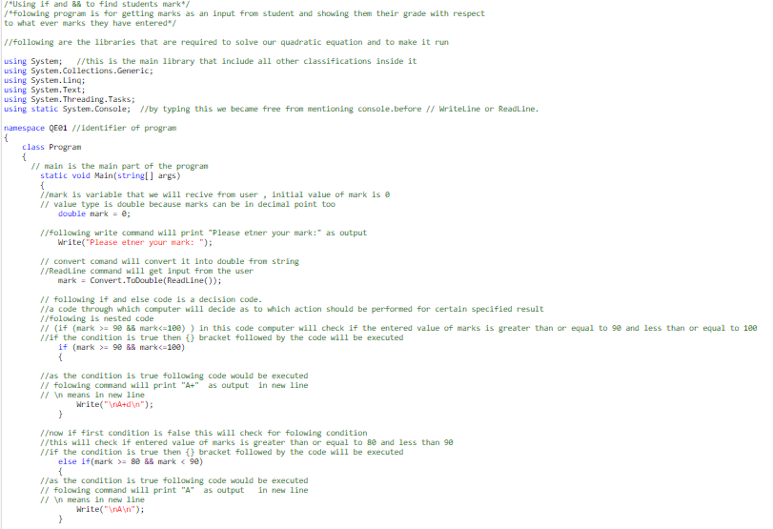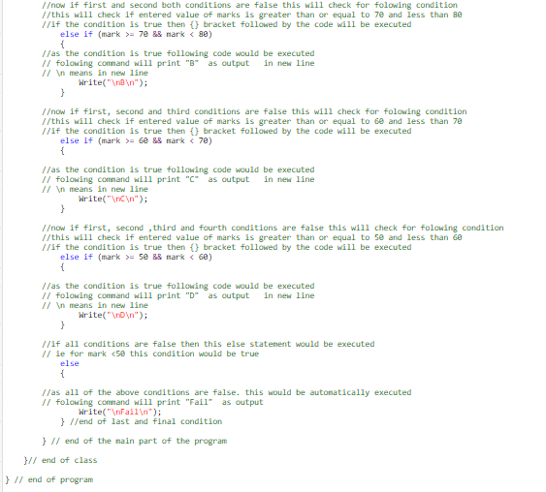

# **Program 04 (Using wiser method to find students mark)**

Quick link: - <https://dotnetfiddle.net/sKBIgi>

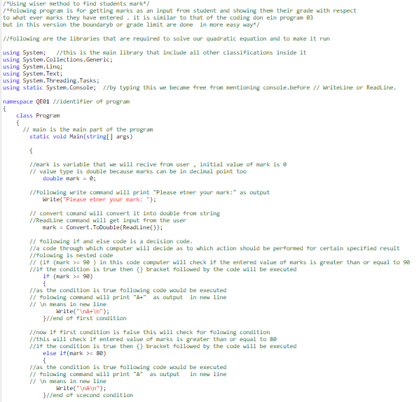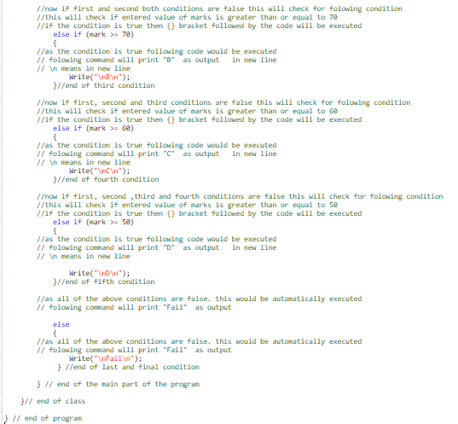

# **Program 05 (Using ternary operator in C#)**

Quick link: - <https://dotnetfiddle.net/ZU9nRq>

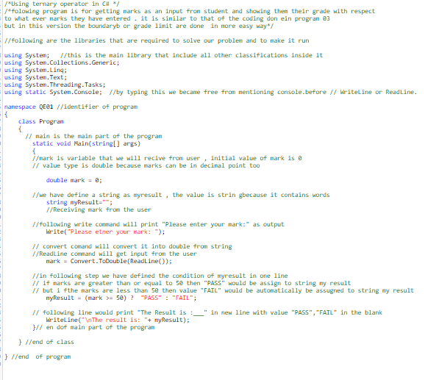

# **Program 06 (Simple usage of for loop in C#)**

Quick link: - <https://dotnetfiddle.net/L9RAdO>

